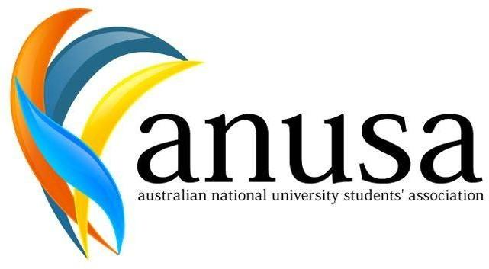

AUSTRALIAN NATIONAL UNIVERSITY STUDENTS’ ASSOCIATION The Australian National University

Canberra ACT 0200
T: +61 02 6125 2444
E: sa.gensec@anu.edu.au
http://anusa.com.au

Notice of Meeting:
Student Representative Council (SRC) 2 2022

Date: Wednesday, 23 March 2022

Time: 6:15pm

Location: Zoom

Can I come?

ANUSA Council meetings are open to all undergraduate students at the ANU.

If you wish to submit a motion, please email it to the General Secretary by COB 18th March. Refer to this guideline of the process for submitting a motion: https://anu365-my.sharepoint.com/:b:/g/personal/u6677850_anu_edu_au/EXb5NdbvYOdFnXmLzebcJKYBqYuG-06Vu9cSM5jAqQhk3A?e=KqsMp1.

If you have any questions, please don’t hesitate to contact sa.gensec@anu.edu.au.

Ben Yates
General Secretary
25 January 2022

